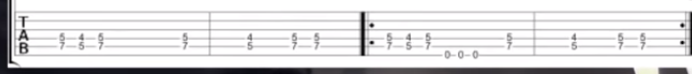

Master of Sparks - ZZ Top
A minor 125 bpm
A A A E
A A A D
E A A D

High class Slim came floatin' in
Down from the county line.
Just gettin' right on Saturday night,
Ridin' with some friends of mine.
They invited me just to come and see
Just what was on their minds
And then I took my first long look
At the Master of Sparks on high.

In the back of Jimmy's Mack
Stood a round steel cage
Welded into shape by Slim,
Made out of sucker gauge.
How fine, they cried, now with you inside,
Strapped in there safe and sound.
I thought, my-o-my, how the sparks will fly
If that thing ever hit the ground.

Slim was so pleased when I had eased
Into his trap of death.
He had slammed the door but I said no more
And I thought I'd breathed my last breath.
We was out in the sticks down Highway Six
And the crowd was just about right.
The speed was too, so out I flew
Like a stick of rollin' dynamite.

solo -

When I hit the ground you could hear the sound
And see the sparks a country mile.
End over end I began to spin
But the ball started runnin' wild.
But it was too late as I met my fate
And the ball started gettin' hot.
But through the sparks and the flame I knew that the claim
Of the Master of Sparks was gone.

solo

